a) **About Our Project**

The project we designed is a website implementing a hotel reservation system. Our hotel name is “MOONLIGHT” and this name not just reflects the shining aspect and the calmness of our hotel but also show our readiness to serve all our clients at any time during the day or the night. In our website the user has the ability to view all the available rooms under the “rooms” page, and explore all our hotel features and services under the Book now page, and to search for his desired room according to his preferences (check in check out dates, number of beds) and book it after logging in our creating his account. The user is surely allowed to view his past and current reservation.

**Our Home page:**

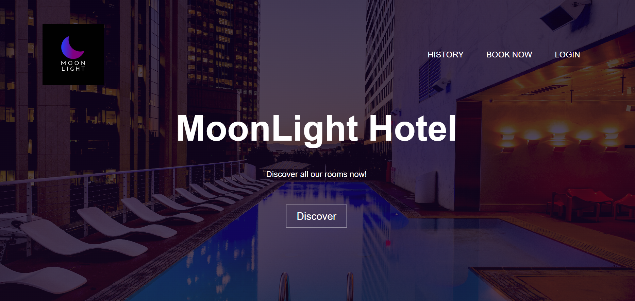

**Some pics showing the frontend work in our book now page:**

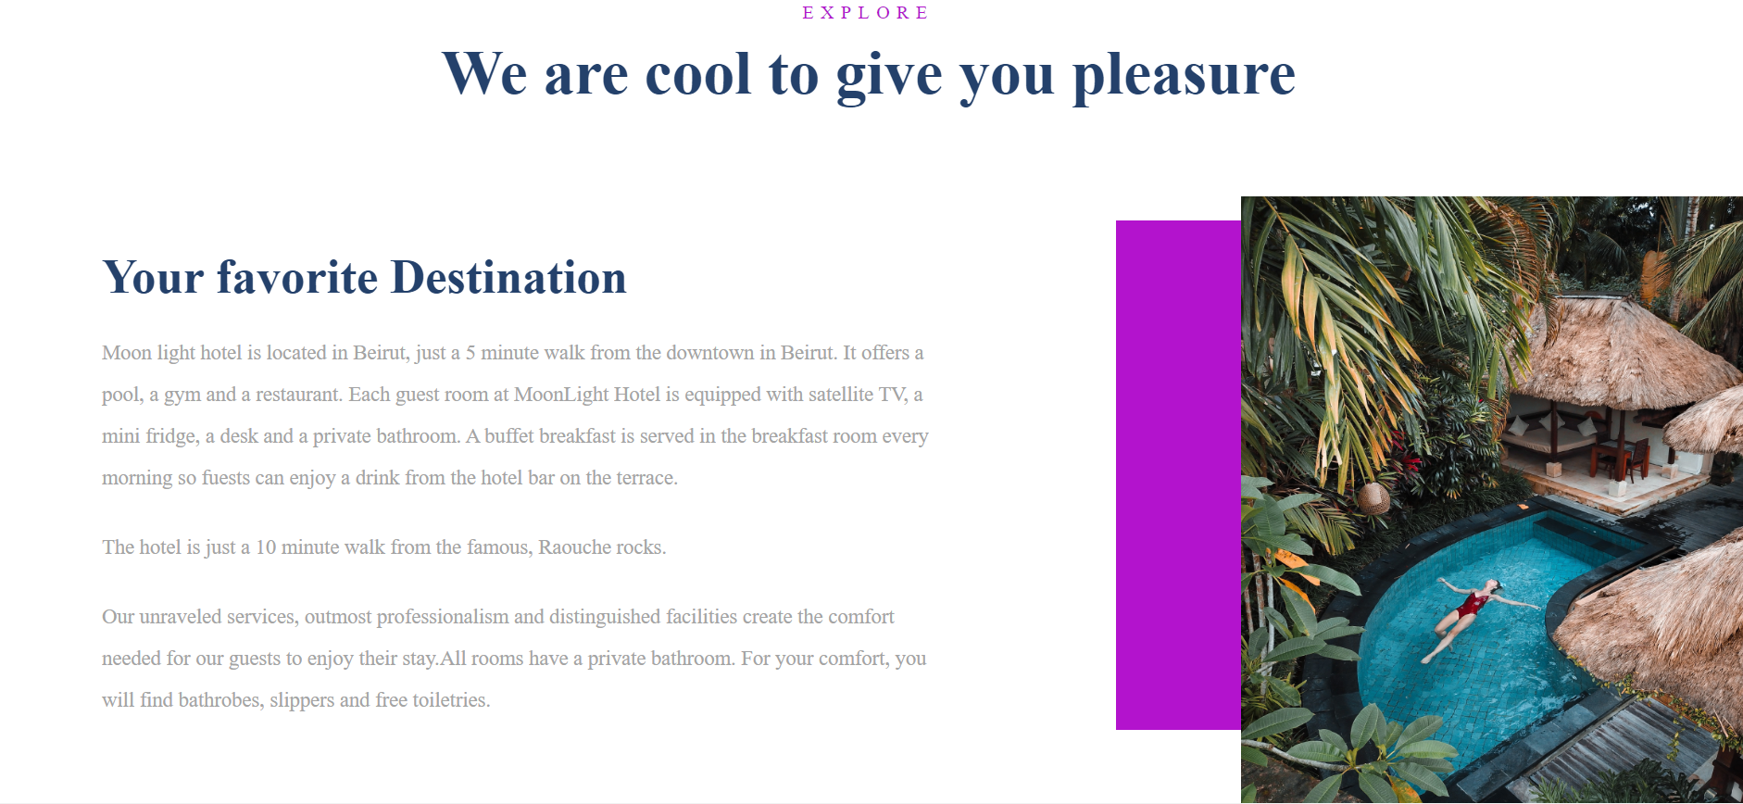

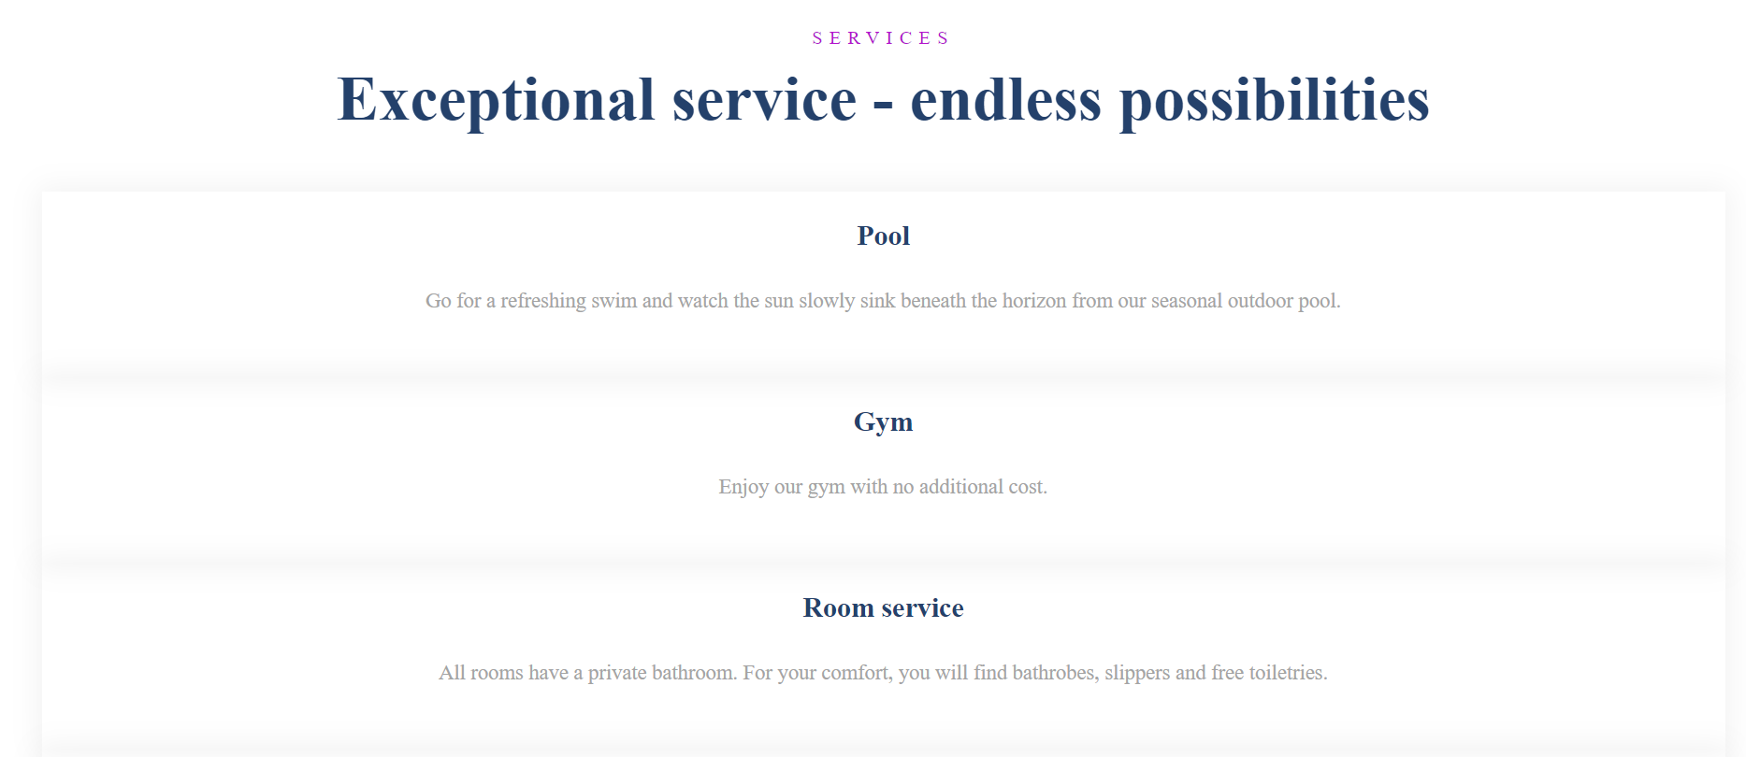

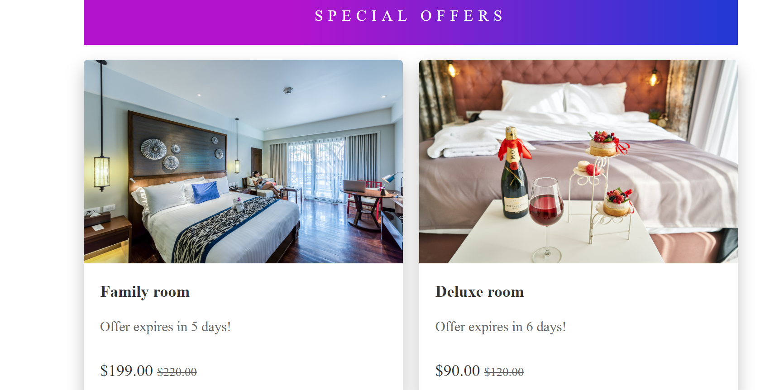

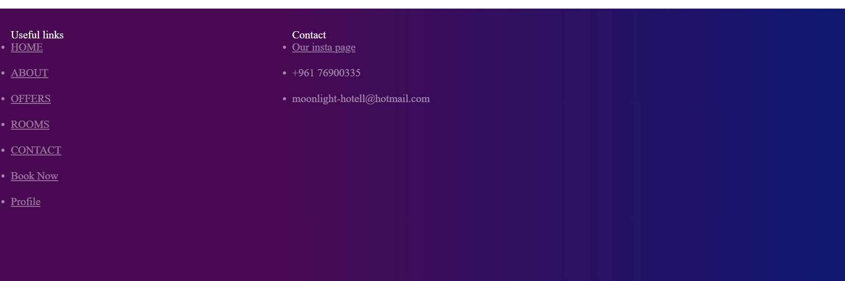

**Our room search system**

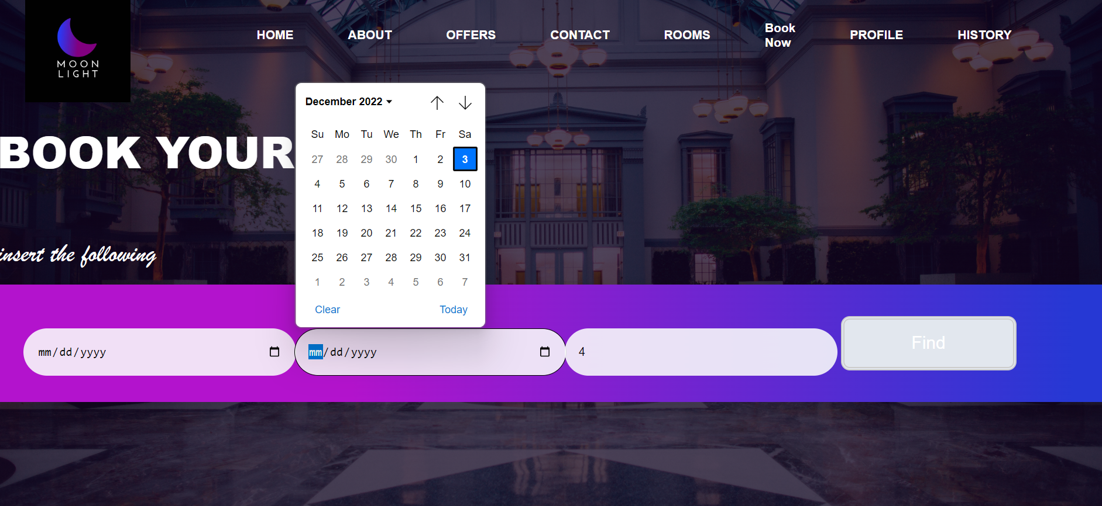

b) **Brief Overview of the Code’s Structure**

We used HTML, CSS for the front end and we putted sufficient effort and time in designing every page to please the user view where we worked on organizing our html files and in putting a good design to every single page using css.

**Screenshot showing an html file:**

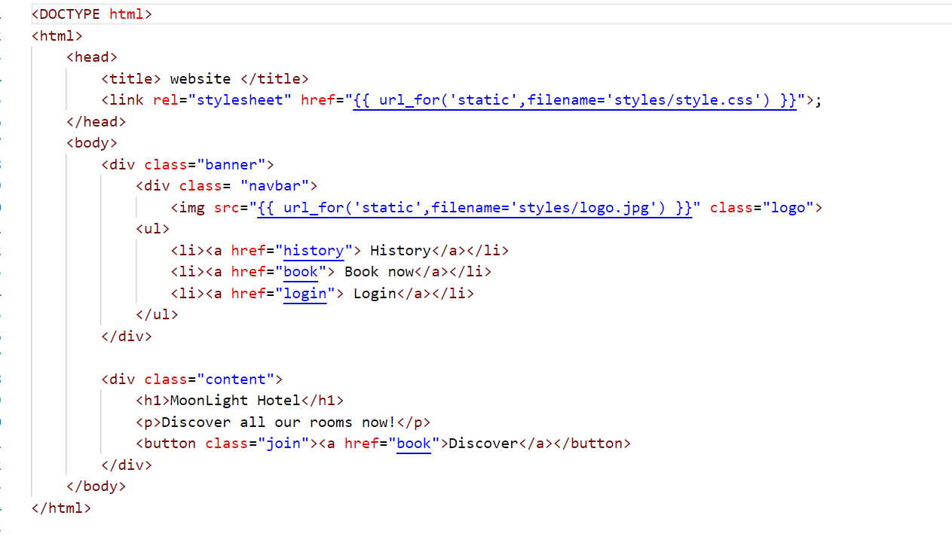

**Screenshot showing a css file:**

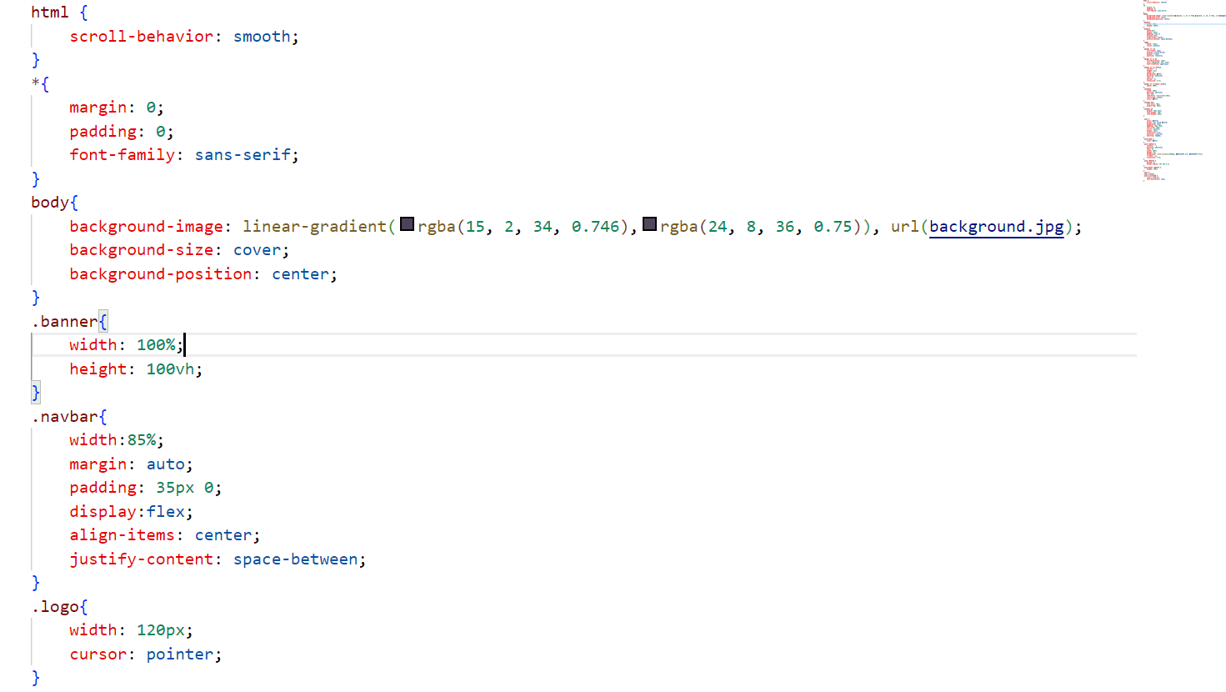

**Screenshot showing the different colors and beautiful aspect of our pages using css:**

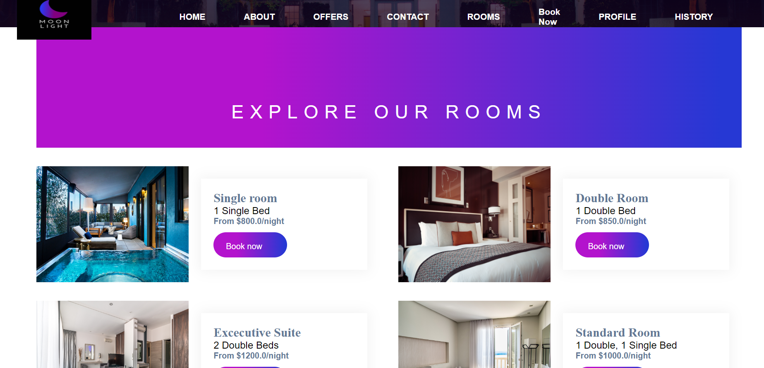

We used Python for the backend.

The framework we used is flask.

We used a template render engine called Jinja2.

We started by creating all the html pages for our website as static pages. Then we used css to style them. After that in our app.py file we created the endpoints for each directory. Then we started by working on the backend of our pages one by one converting the ones needed from static to dynamic to cope with specific users and user input. Testing each part alone and each function alone then combining the code and testing.

**Screenshot showing some of our backend code:**

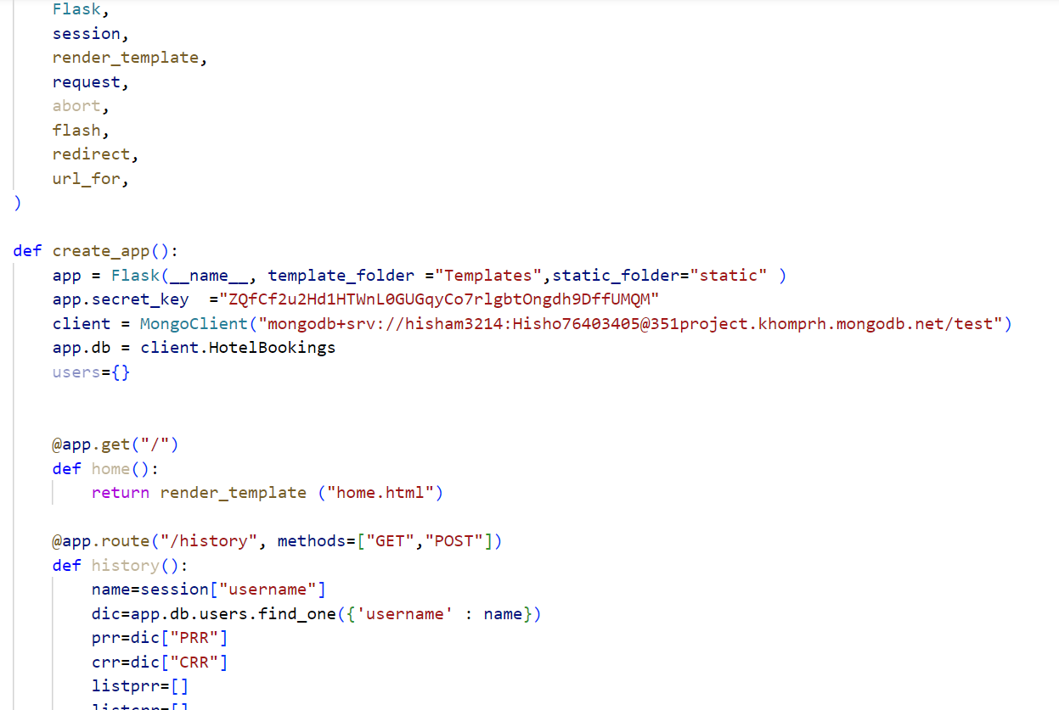

We used the PassLib library to hash the user’s password and provide more security.

We used the secrets library to use token_urlsafe to generate a very secure secret key for our app

We used a Non-SQL database called MongoDB.

c) **Database Design**

We were already familiar with SQL databases so we decided to use a non-SQL database and thought of it as a learning opportunity. We used MongoDB which is a document based database. We created a database for this app on the MongoDB cloud and in this database we created clusters. We created 2 clusters, one for the users and one for the rooms. In the users cluster when a user signs up we create a document for this user containing all his information in addition to 2 embedded documents that contain currently reserved rooms of this user(CRR) and all previously booked rooms of this user(PRR).

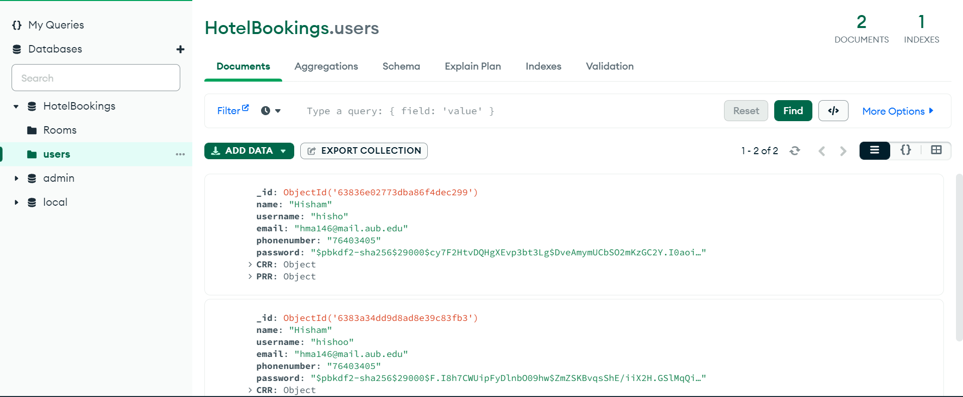

As for the rooms we created a document for each room in the hotel.

Each document contains all the information about the room and an embeded document containing the dates to check for available dates when the user is searching for their desired rooms.

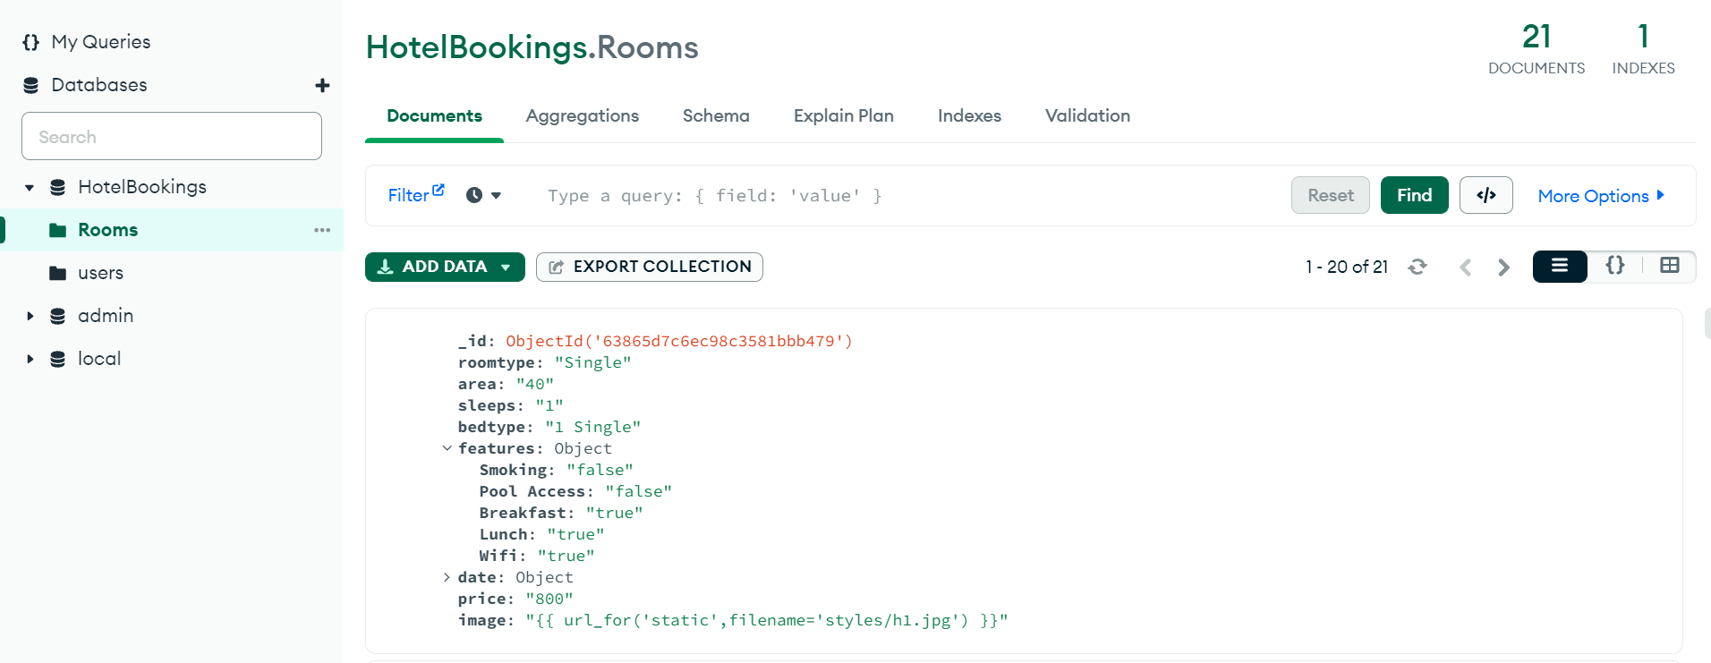

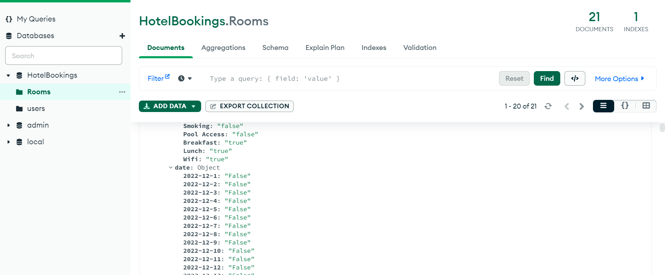

d)**Features of the Code and Decisions Taken:**

Log in page: This page is implemented for users who already have an account in our website. The user must enter his email and password, after doing so we check if a username exists in our database if yes we retrieve the password that is already hashed and stored in the hashed form, this hashed form contains with it the salt and rounds which is used to hash entered password and compare it to previously hashed and stored password if they match our records we save the user’s username in the session and retrieve the cookie and then redirect to home page. We hash entered password not unhash the one in database to minimize risk of password leak.

**Screenshots showing our log in page:**

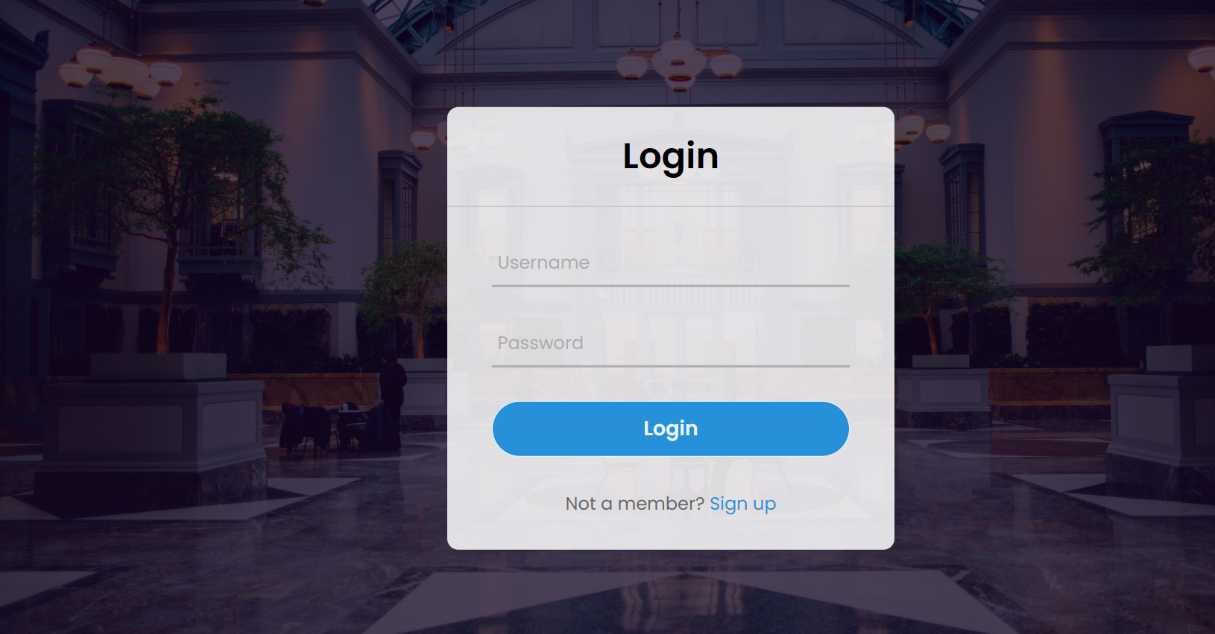

Sign up page: This page is implemented for users who are interested to create an account in our website for the first time. To do so the user is asked to enter some info (name, email…) and to create a strong password (with some conditions on the password). After submitting these info, we checked if the entered username is already in our database, if so the user is asked to log in instead, otherwise a new record is created for the user in our database, if something is wrong and register is clicked an error message appears but fields that are okay remain unchanged. Before we enter password in database we hash it with passlib that picks a random hash function and hashes it a certain number of rounds. So a very secure almost uncrackable password is stored in database.

Use a post method in order for sensitive information not to appear in url.

**Screenshots showing the functionality of our sign-up page:**

**Handling the already taken username issue:**

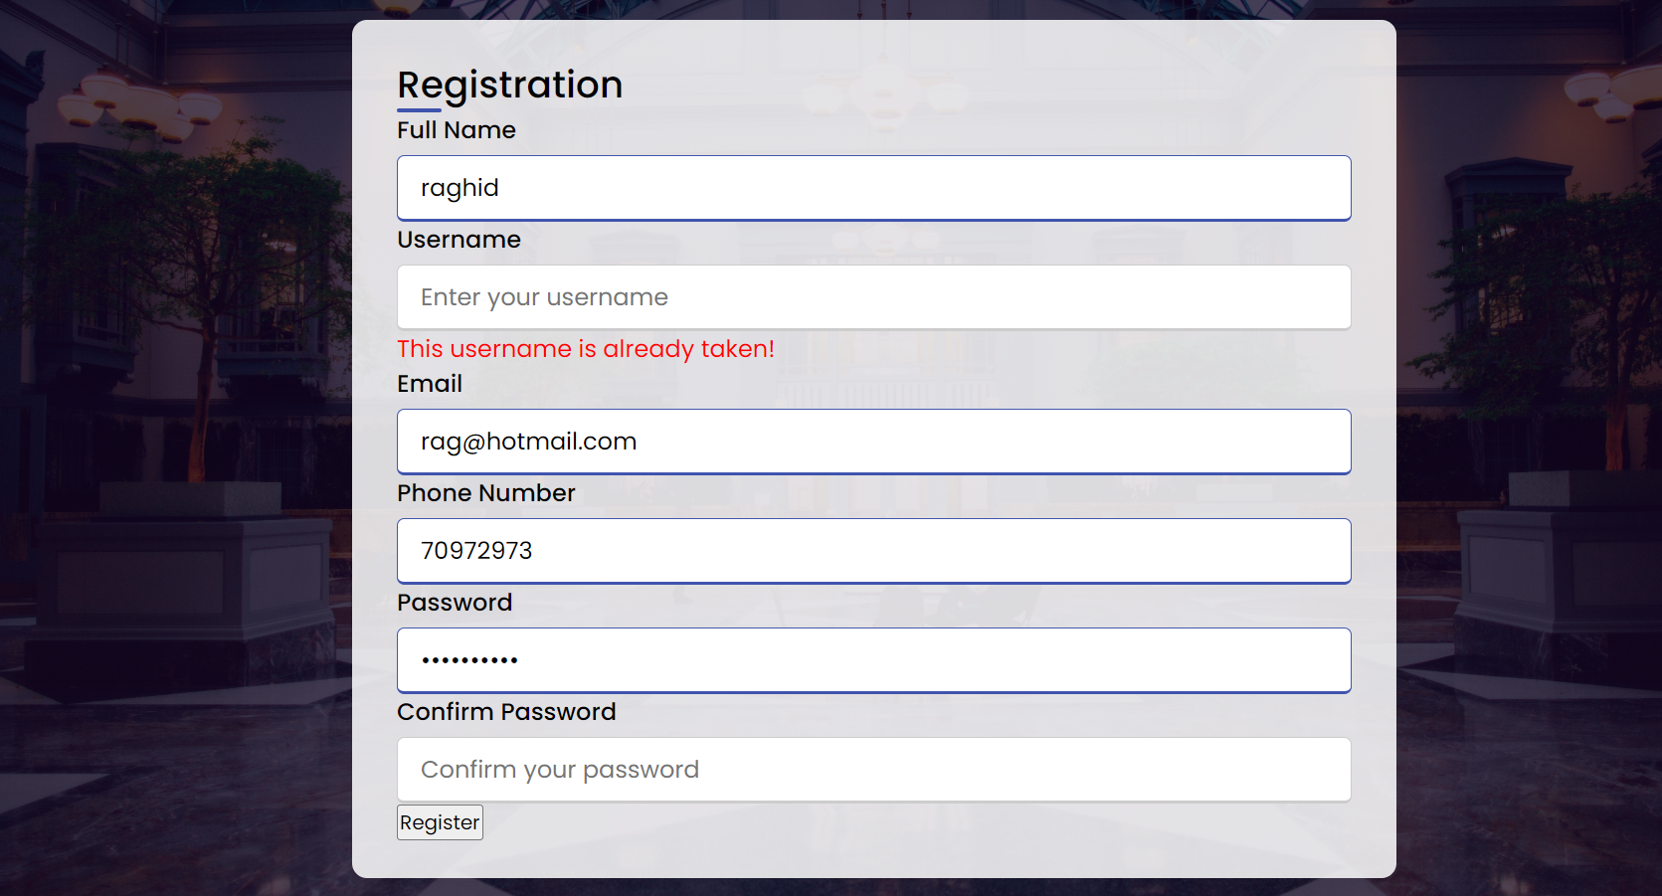

**Handling the password issues (does not match and conditions):**

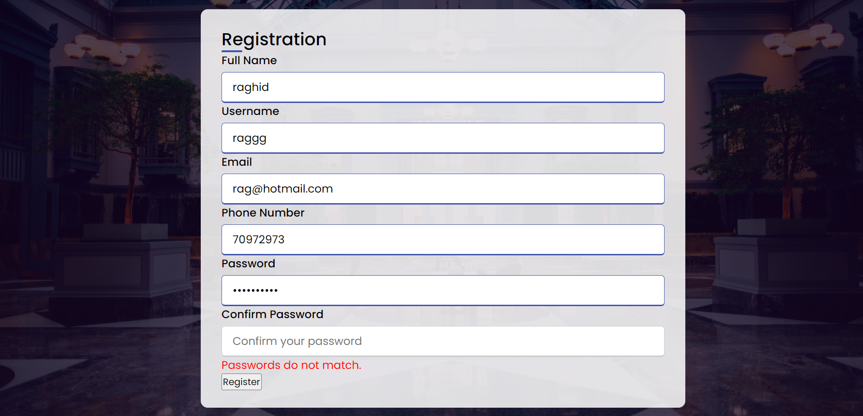

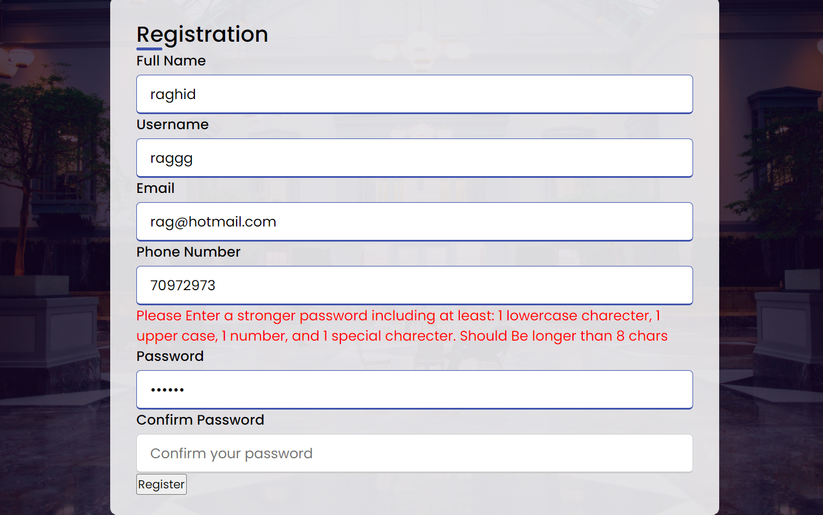

We have a page to display all rooms statically.



We have a page that the user inputs the date they want to stay and how many people. We receive this in the backend and check if date is not in the past and if len>0 and persons>0 and we send a query to check for rooms that are available in the dates and satisfy the persons staying and return search results in a page by sending the results of query in a list of dictionaries to html and there we display them using jinja2 engine.

**Search Page:**



**Results of the search page:  
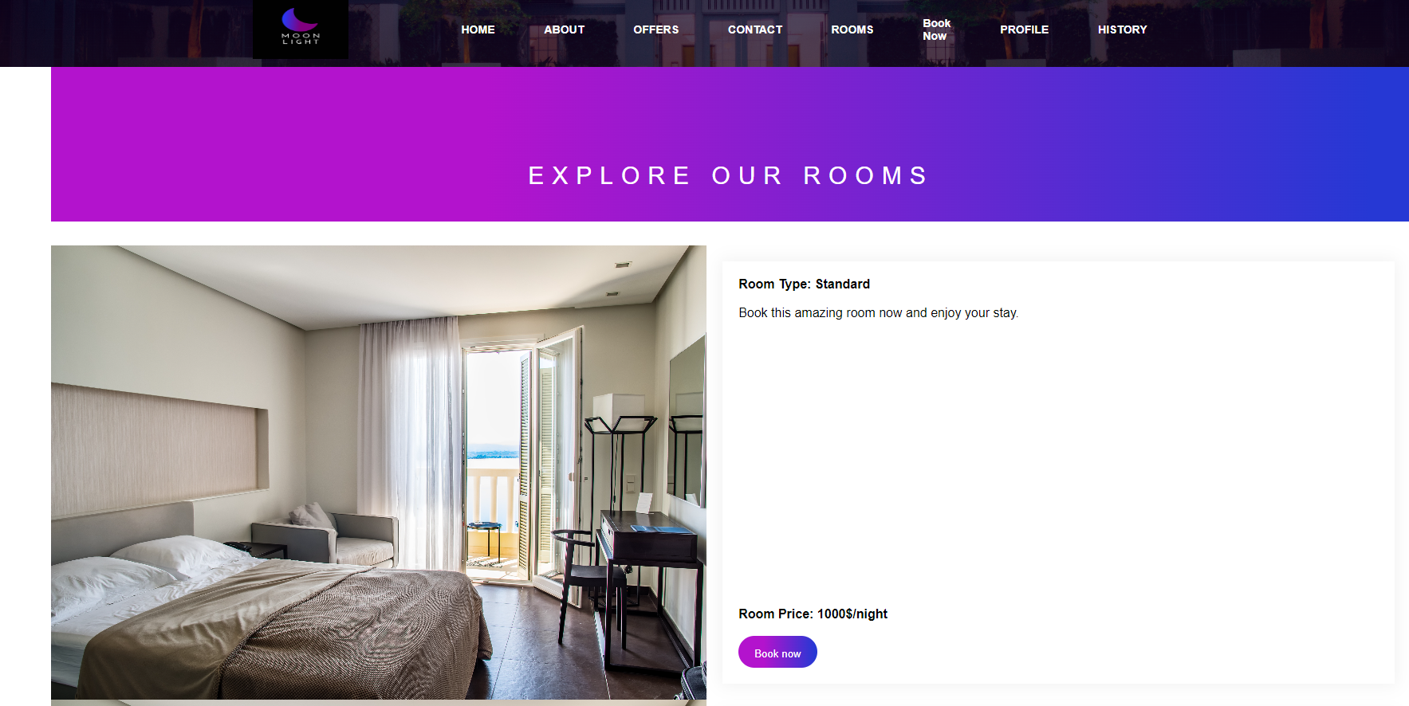**

When browsing through search results the user could book the room and through the session info we know the username and date and so we save the room in their currently and past reserved rooms and change availability in these dates in rooms database to false.

When they press book now they are redirected to an invoice

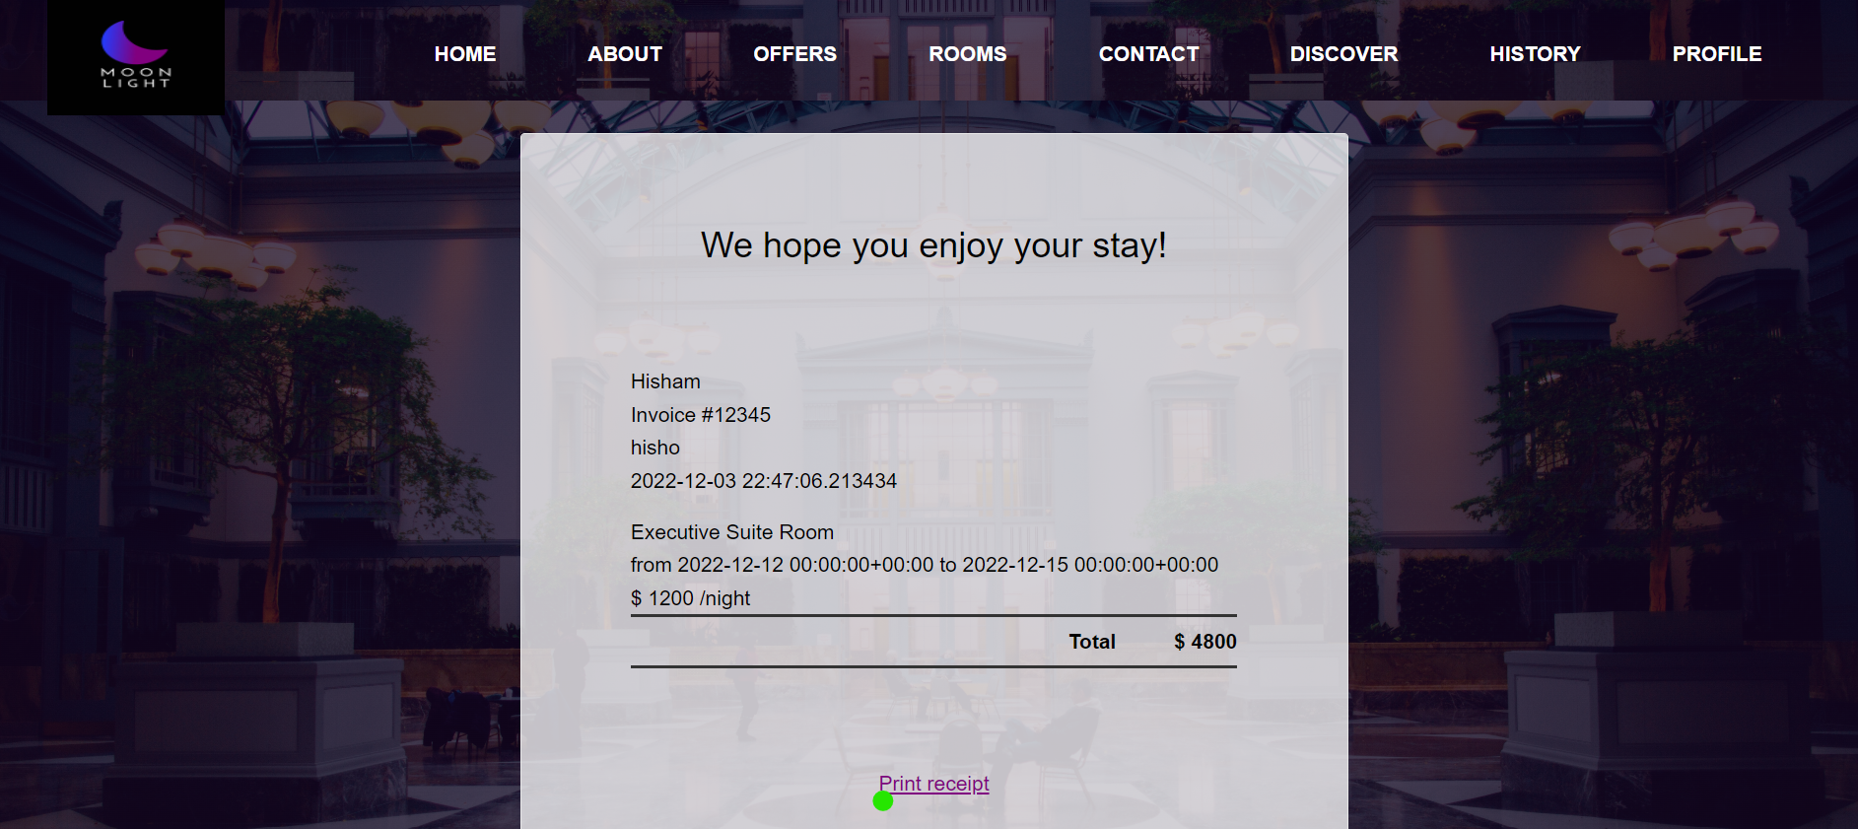

The user has the ability to view their history. Currently reserved rooms and passed reserved rooms.

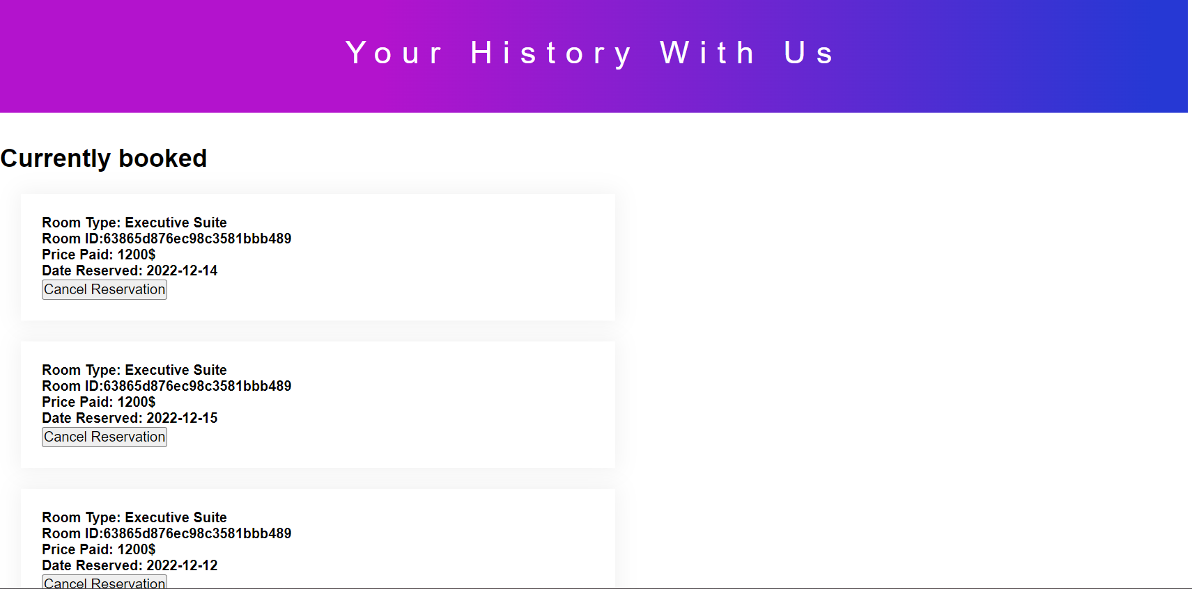

The user could view their profile and edit his info or change password

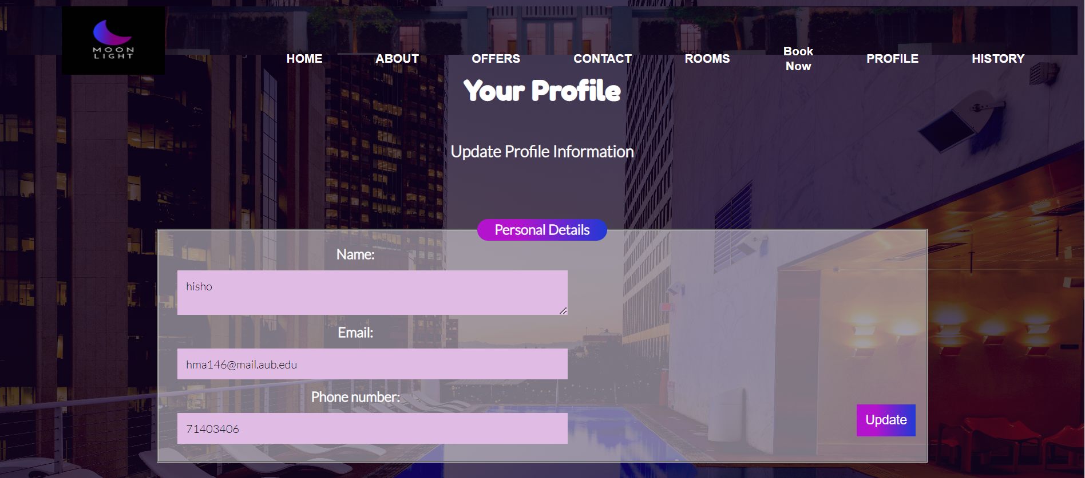

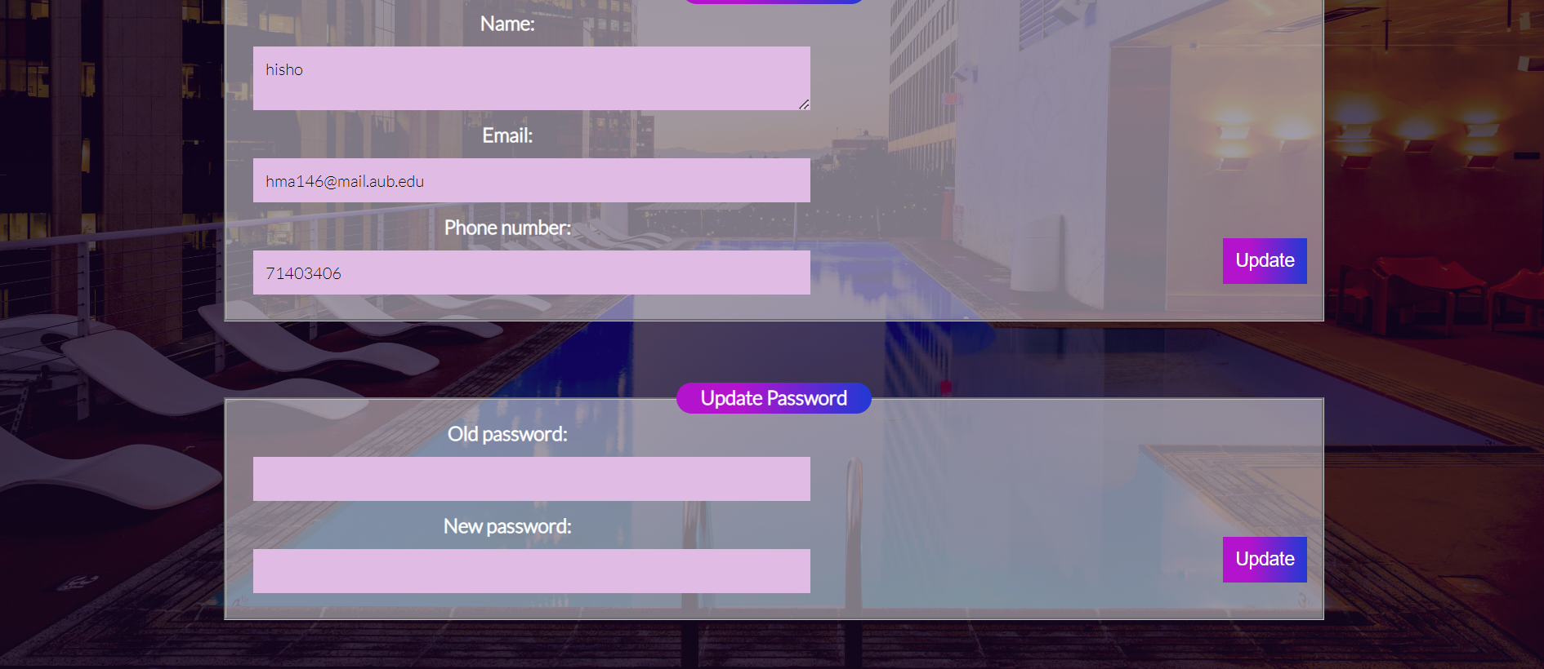

e) **Group Members’ Contribution**

Lynn worked on the frontend.

Raghid worked on frontend and backend.

Mohammad Shaker worked on backend and database.

Hisham worked on backend, database, and render template and organized the tasks.